I have always found it handy when lecturers would provide handouts during heavy topics, so please refer to this if you would like to.
Aim:
What are covenants; why does God make them; name some important covenants; what are the implications of the covenants in our knowledge and walk with God

Define the word covenant
It’s a word God uses to describe His r_____________ with His people.
It is a conditional promise, formalised in a legal agreement or framework with God and humans, where God promises b___________ if His conditions are kept and threatens curses if the conditions are broken.
It is solemnised by sacrifice and guaranteed through o_____.

Why look at the covenants?
Matthew 26:28 “For this is My blood of the new covenant, which is shed for many for the remission of sins.”

God created a covenant with the first rulers Adam and Eve
God asked for p________ o_________ from Adam and Eve and to fulfil what He had commanded them to do.
What was the benefit of doing what God had commanded them to do?

What happened because the failed to do what God had commanded them to do?

Why is Christ better than Adam?
Adam | Christ

God created a covenant with Noah (found grace in the eyes of the Lord)
U____________ promise.
Why did God send the flood?

What’s the difference between common grace and saving grace?

Faithful Abraham received a covenant.
His family, his descendants, and the seed of his descendants, which was Christ Himself, would be the means of blessing the world and that He would see it through.
What’s the significance of the animal sacrificial ceremony?
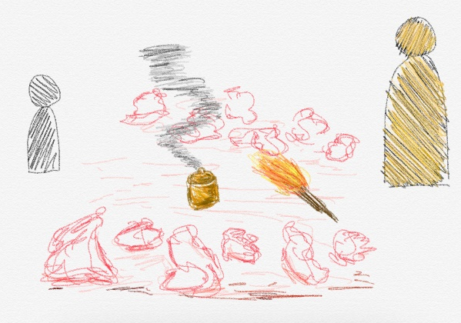
What is God going to do?

What’s the purpose of circumcision?

Where does Faith come into the picture and what’s its importance?

The covenant to A________ and E______ relied on the people living a sinless life in order to inherit their reward. This is known as the Covenant of Works.
The covenant established with Abraham is a covenant of g_______ where we can’t earn salvation by our good works, but instead trust God to provide it for us.

What does the word justified mean?

Abraham was saved by GRACE ALONE! When we’re saved by GRACE ALONE, it means we are saved by GOD ALONE! God, not Abraham, will repair the damage done by Adam
We were cursed. The law cannot justify us. The just shall live by faith. Christ redeemed us from the curse of the law by becoming a curse for us that the blessing of Abraham might come upon the Gentiles in Christ Jesus, that we might receive the promise of the Spirit through faith.
We are justified by faith.

God made a covenant with Mediator Moses
Exodus 19. God wanted the people to be “a kingdom of _________ and a h_______ n_________”.
Exodus 20. Introduced to the 10 ___________________ as well as all the other laws.
Exodus 24. People respond to Moses reading the Book of the Covenant: “All that the Lord has said we will do and be o__________________.”
Exodus 24. Impatient had built the golden calf and worshipped it as God. God spared them for the sake of Moses.

Which two commandments did they break?

This covenant will be replaced by the New Covenant.

God made a covenant with King David
What is the covenant?

Who is the Son of David?

Faithful God who creates promises with a rebellious people who breaks them and therefore bear the curse.
New Covenant
What was the significance of the fault with the Old Covenant (Mediator Moses)?

The Old Covenant was based on o_________.
The New Covenant is founded on p__________.

The Old Covenant was all about “you shall,” and the obligation sat on the ability of the p_________.
The New Covenant is all about “I will” and the obligation sits on the ability of G____.
God transforms our desires and abilities. We can’t do it ourselves.

God’s R___________________ revealed to us through faith in Jesus Christ (which is the law of God written in our hearts) is CREATED by God restoring His R______________ with us and being adopted into His family (so that we can actually know God as revealed in his W_______), which is the blessing CAUSED to us by God’s R_______________ work on the cross.

Define righteousness

Righteousness is obtained by faith. It’s not by keeping the Law of Moses as the Jews would have done.
Faith in God leads to salvation and God’s righteousness revealed.

God’s grace will perfect, establish, strengthen, and settle you.

Understanding the Laws in the light of the New Covenant
The law that is written in our hearts is the very same law that God gave to Moses on Mount Sinai.

Old Covenant: E_________ law, written on tablets of stone
New Covenant: I_________, written by the Spirit of God in our hearts and in our minds.
New Covenant does not abolish the Law or the Prophets. Christ came to fulfil.
The Law is a revelation of the moral c______________ of God, and therefore the Law is unchanging.
What does it mean to be in the image of God, Imago Dei?

Why was the Law given?

What happens when God’s law is written in your hearts?

Where can you find the 10 new promises if you live in Jesus Christ?

In the New Covenant, the law is fulfilled by the life of Jesus Christ inside of us by His Holy Spirit, so God creates a hunger and a thirst for r_________________.
God works in you to desire and to do according to His purposes.
We can know God by faith, because he sought us out through grace.

We are first justified through faith by the imputation of Christ’s righteousness, so that we can then be united to Christ and all our debts become His, and all of His riches become ours. Adam was our federal head. Christ becomes our covenantal head.
God brings us down to the point of being, feeling, experiencing and believing that we are the least before He begins to build us up.
We can only receive the knowledge of God in humility.
Removal of Sin
Under the Old Covenant sin was only covered, not removed. It did not transform anybody because it needed constant repetition.
Illustration of Check
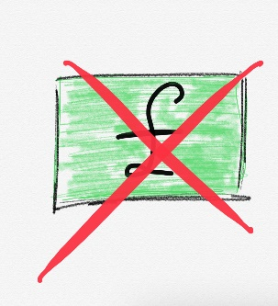
Cheque = Intrinsically worthless piece of paper
If I were to write your name and one million pounds, sign it and give it. Provided that I have one million pounds in my bank account, you can take it to your bank and cash it as yours.
Fine, just give me a cheque post-dated to the 1st of the next month
I get my salary on 1st of the month
You owe me money!

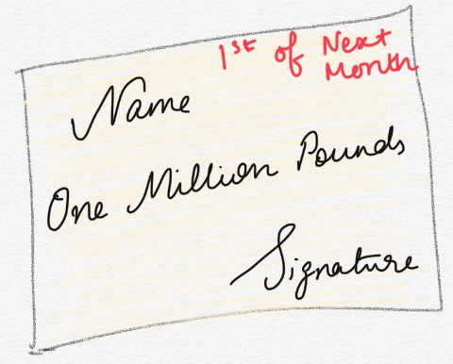
Today

It sits in your home for the rest of this month, again a worthless piece of paper.
The debt is covered, not removed.
1st of Next Month

On the first of the month you go into the bank and you pass it over and it suddenly becomes one million pounds transferred into your account.

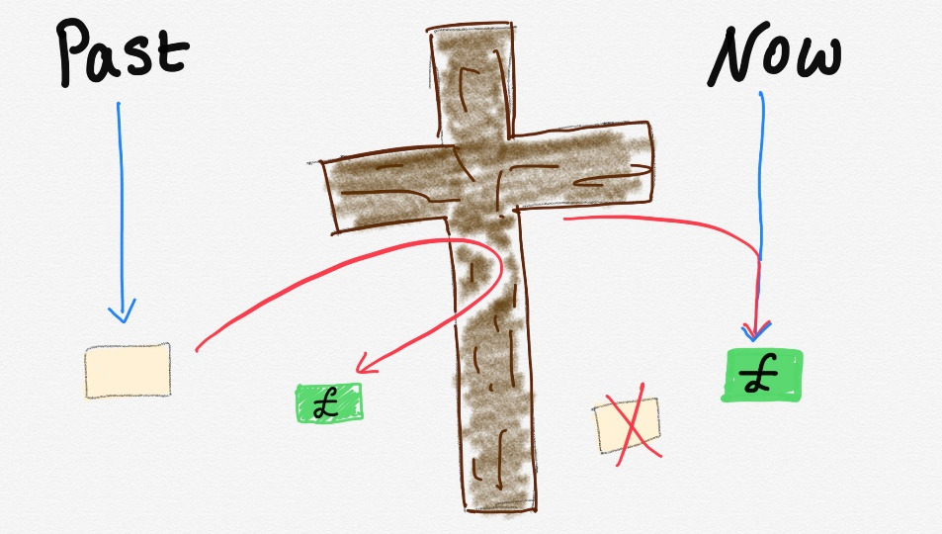
Before:

When Jesus said TETELESTAI “It is finished!”:

What about us:

New Covenant:
Christ’s righteousness imputed to us, so when God looks at us, He sees the perfection of His Son, and the law of God will work in our hearts and in our minds to transform us into the new man with a new heart.
Reflection/Discussion Questions
- What are the overarching themes of the Covenants?

- Why is God’s Covenant with Adam and Eve important?

- What was the significance of God passing through the animal sacrifices performed by Abram?

- How is Faith described in the Bible?

- Pharaoh’s heart was described as hardened. What should our response to God be to prevent us from having a hardened heart?

- Why does the law become promises?

- Why do we need Salvation and how do we obtain it?

- Does salvation mean I can live my life however I want to, and God is fine with it?

